2022

Nigeria Youth Peace Leadership Camp Report

Theme-Young Persons as Catalyst for Democratic Change in 2023
Our Project-Future Peace
Venue: Sacred Heart Seminary, Artillery, Beside Ciwa Aba Road, Port Harcourt.
Date:23rd -27th August 2022.

Edited by Iwuamadi Chimaobi Sunday
Ag. Coordinator

Afripeace Sustainable Development Foundation
14/11/2022

2022 NIGERIA YOUTH PEACE CAMP COMPLETION REPORT

IDENTIFYING INFORMATION
Project Title: Young Persons as Catalyst for Democratic Change in 2023

Type of Project: Education and Training

Project Proponent: Center for Social Transformation and Human Development
(CHDST) and Konrad Adenauer Stiftung in collaboration with Afripeace Sustainable Development Foundation.

Number of Beneficiaries: 12 Secondary Schools-7(Rivers State) 3 (Imo State)
2(Bayelsa) 11 Staffs and Teacher Coordinators and 47 Secondary School Students.

Program Supervisors: Rev Father Polycarp Henetu, Imoh Collins,Chinwe Ekwunife,
Anumaka Clara James, Mrs Chinelo,Mrs Uwah M.C

Speakers and Facilitators: Barrister Chinwendu Azuka, Prof Betty Erula, Dr, Mrs.
Chinwo, Mrs Clara James Barrister Bestman Umoke,Mr. Deihe, Dr Mrs. Minna Okoroafor, Nnadi Amadi Wali Esq.

Place of Program Implementation: Sacred Heart Seminary,ArtilleryBeside
Ciwa,Aba Road,Port Harcourt.

Program Sponsors:
- Center for Social Transformation and Human Development (CHDST)
- Konrad Adenauer Stiftung
- Prof Ernest E. Uwazie Foundation
- Afripeace Sustainable Development Foundation.

EXECUTIVE SUMMARY
The Protect our Future Project which is a yearly camp program organized for Secondary schools with Peace clubs across the Niger Delta by Center for Social Transformation and Human Development (CHDST) was held for five days at Sacred Heart Seminary, Ciwa Aba Road, Port Harcourt from 23rd -27th August 2022.
The camp brought members of peace clubs and students from Rivers, Imo state and Bayelsa to learn, be equipped and sensitized about Peace and Democracy with focus on young persons as catalyst for democratic change 2023. This was poised for a future with enlightened young persons in the country for a total change. It was an opportunity for students to ask question and get the right answers with guidance on the right thing to do.

Theme of interaction young persons as catalyst for democratic change 2023 stirred up the student’s zeal to become agents of change in the society. It featured topics such as understanding democracy and how it works, Going the extra mile to facilitate a change in 2023, Sustainable development goals (SDG), Creating awareness on human trafficking, Young person’s sustaining democratic change, Court and its application, Creating a new reality and No to all forms of vices to our progress.

The resource persons cut across various fields from Lecturers, management consultants, Doctors and peace practitioners and lawyers. They drew from their wealth of experience to present an educative, interactive and motivating peace camp. There were opportunities for outdoor events and the students had the unique experience of visiting the High Court. The excursion visit exposed the students the dynamics of democracy in action. Students were privileged to interact with the lawyers, had site seeing and were provide with answer to the questions asked.
The strategy session of the peace camp was used as an avenue to plan for the expansion of peace clubs. The youth Peace camp participants were supplied with writing materials, daily feeding (breakfast/lunch and dinner) and T-Shirts for Identification.

The total number of participants for the camp were 62.

PROGRAMME OF ACTIVITIES FOR THE PEACE CAMP DAY 1
Opening: An opening prayer was said by Mrs. Chinwe of Center for Social Transformation and Human Development (CHDST) afterward, everyone was welcome.

Arrival/Registration: The students were registered by the Center for Social Transformation and Human Development (CHDST).

Ground Rules: The camp coordinator Mrs. Chinwe read the rules and regulation that will be governing the camp and encouraged all the students to adhere to it. Students were advised to conduct themselves in an orderly manner and observed all the lecture and boarding protocols

Briefing of Participants: Mrs. Chinwe on behalf of the executive director welcomed the participant to the 2022 camp meeting both students and teacher coordinators from the different states. She appreciated their efforts so far with the view of developing a peaceful and democratic society through young persons. The camp is well defined with an important theme- young persons as catalyst for democratic change 2023. Everyone have a role to play and young persons are vital tools. Let’s position our minds and conscience to learn and be developed. Feel free and be good. God bless us.

Group Sharing: The students were divided into four groups and teacher coordinators were attached. The group
- Peace
- Unity
- Love
- Progress
The groups are to perform their different functions for the effective running of the peace camp. Different groups will be responsible for cleaning the boarding rooms, Lecture hall, washing of the bathrooms and the toilets daily.

1st lecture-Understanding Democracy and how it works by Barrister Chinwendu Azuka
The principles of democracy were highlighted as popular, sovereignty and equality of opportunities as well as the difference between the three arms of government.

DAY 2
The morning activities in respect to exercise, morning devotion and clean-up of the boarding facility were carried out by the students with supervision of the teacher coordinators.

Lectures;
Going the extra mile to facilitate a change in 2023 by Prof Betty Erula. Highlights of her lectures were a breakdown of the acronyms BETTY meaning B-Bringing, E- Edifying, T-Truth, T-To, Y-Youths. Also portrayed the five magic words that makes peace to exist as follows; please, excuse, sorry, thank you and pardon me. Ways to achieving extra mile that will facilitate change one must be,

- A responsible citizen
- Participate in democracy
- Adapt the 3Ds-Determination, devotion and dedication and all amounts to Deligence.
- Adapt the 3Cs-Critical thinking, Collaboration and cooperation.
- By ensuring high degree of literacy and adopting the 3Gs-Going, Giving and Grooming.

2nd Lecture- Creating awareness on human trafficking
The lecture provided definition, causes and things to avoid on human trafficking.

3rd Lecture- SDG by Doctor Mrs. Chinwo
Participants were made to know that the SDG means Sustainable Development Goals which is the framework for development and planning in the society and was adapted in 2015. SDGs was put in place to address the problems of the common people and to improve the quality life of citizens. There are 17 SDGs as follows; Poverty, Zero Hunger ,Health & well-being, quality education, quality gender, water& sensitization, renewable energy, good job &economic growth, innovation, infrastructure and industry, reduced inequalities across countries, sustainable cities and communities, responsible consumption, protect the planet, life below water, life on land, peaceful & inclusive society e.g crime and partnership for the goals.

4th Lecture-Young person’s sustaining democratic change by Barrister Bestman Umoke.
5th Lecture-Court and Its Application by Nnamdi Amadi Wali Esq.

DAY 3

Excursion Day
Visit to Magistrate Court
This was an opportunity for outdoor activity to learn and have site seeing. The students had a unique experience visiting the Magistrate Court. The excursion visit exposed the students to the dynamics of democracy and the law in action. Students were privileged to interact with the lawyers, had site seeing around the court to the conference hall, internet/strong room(server) correctional cell, etc Participants were provide with answer to the questions asked.

Lectures continues;
- Creating a new reality by Mr. Deihe People
- No to all forms of vices to our progress by Dr Mrs. Minna Okoroafor
- Group work/Presentation
- Questions and Answers

Quiz Competition
Afripeace sustainable development foundation the sole sponsors of the quiz competition, brought in this initiative to the peace camp so as to ignite the zeal in student to participate in academic related competitions as a sprout for continuous learning. This process engaged all the students in the camp from Rivers state, Imo State and Bayelsa and was coordinated by Mr. Obiji
L.C. The competition questions cut across, Sciences, Peace education, Mathematics, English language and current affairs. Participants were merged together to form three group for the quiz competition- Rivers team, Imo team and Bayelsa team. The quiz competition had 60 questions across the subjects and lasted for 1hr 30mins. In conclusion, the results were presented as follows; 1st position-Rivers team, 2nd position-Bayelsa and 3rd position-Imo. They were all presented with their prizes accordingly.

DAY 4 – (Last Day)
The program successful got to the grand finale which is the last day of the camp. It is a norm on the last day to ensure the these following activities to be listed are conducted- Student’s acknowledgement, certificate presentation and the word for the road. ‘’It’s been a great camp outing and engagement’’- The organizers, teacher coordinators and student exclaimed.

PRESENTATION OF CERTIFICATE
Certificate of participation was given to the participants (students only) and was presented by Mrs. Chinwe of Centre for Social Transformation and Human Development, some facilitators and Mrs. Uwah representing Afripeace Sustainable development foundation.

- Evaluation: All students submitted a written one page note of their experience in the camp with what they have learnt. This session was carried out to ascertain the impact the camp has had on the student participants.
- Peace Camp Experience report by all students

Closing remark
Due the virtue of time the coordinator from Center for Social Transformation and Human Development (CHDST) appreciated and encouraged all the students to put in their best to ensuring active engagement in academic studies as well as ensuring they develop their talent and basic skills. More so, to be young persons who will be catalyst for democratic change in 2023. Sustain the momentum on peace building in the society especially within their school and peers, grow their school peace clubs.

RECOMMENDATIONS
- Peace Education should be included in the school curriculum.
- More schools in the state should participate in the Annual Peace Camp programs
- Boarding and hosting the students in a place is still the best.

FINANCIAL REPORT
Afripeace Sustainable Development Foundation registered 16 students and 3 teacher coordinators into the 2022 peace camp and sponsored their travels alongside 2 BOT members.

PEACE CAMP 2022 INCOME AND EXPENSE

Expenses

S/N | DESCRIPTION |  |  | NUMBER  OF PERSONS | RATE | TOTAL AMOUNT
1 | 2022 IMO STATE PEACE CAMP REGISTRATION |  |  | 16 | N10,000 | N160,00O
2 | TRANSPORT TRU AND FRO  HACOURT AND OWERRI | TO | PORT | 16 | N5,000 | N80,000
3 | LOCAL TRANSPORTATION HARCOURT | IN | PORT | 16 | N400 | N6,400
4 | TEACHER COORDINATORS ALLOWANCE |  |  | 3 | N7,000 | N21,000
5 | TRANSPORT TRU AND FRO TO PORT  HACOURT AND OWERRI FOR SIR OBIJI AND IWUAMADI SUNDAY |  |  | 2 | N5,000 | N10,000
6 | ALLOWANCE FOR SIR OBIJI AND IWUAMADI  SUNDAY (Coordinator ASDF Nigeria) |  |  | 2 | N5,000 | N10,000
7 | QUIZ COMPETITION |  |  | 1 | N25,000 | N25,000
8 | 2022 PEACE CAMP REPORT (Printing and  photocopies) |  |  | 1 | N5,000 | N5,000
9 | MISCELLANEOUS |  |  | 1 | N4,000 | N4,000
TOTAL |  |  |  |  |  | N321,400

TOTAL INCOME= N301,900+19500=N321,400

TOTAL EXPENSES= N321,400

Students Registration
Each student paid a sum of N1,500 to register for the 2022 peace camp. A total of 13 students registered through Afripeace Sustainable Development Foundation
Sum=N19,500.
Total Sum Received- N301,900+19500=N321,400

EXPENSES
The sum of hundred thousand naira(N160,000) only was paid to Center for Social Transformation and Human Development for co-sponsorship of the 2022 peace camp in Rivers State.

Transportation tru and fro Rivers State-N90,000 Local Transport in Rivers State -N6,400 Reporting and editing –N5,000

Teachers Allowance - N15,000
- Mrs M.C Uwah- N5,000
- Mrs Ogechi Ejike-N5,000
- Mr Okeke Emeka-N5,000

Afripeace Sustainable Development Foundation Representative allowance/stipends- N10,000.
- Mr L.C Obiji- N5,000
- Ms.Iwuamadi C. Sunday- N5,000

Quiz Competition
N25,000

Miscellaneous
N4,000
Total Expenses- N321,400

NAMES OF IMO PARTICIPANTS

Afripeace Sustainable Development Foundation Rep
- Iwuamadi Sunday Chimaobi
- Sir L.C Obiji

Teacher Coordinators
- Mrs Martha Uwa C
- Mrs Ogechi Ejike
- Mr Okeke Emeka

Students and Schoools

COMPREHENSIVE SECONDARY SCHOOL UMUEZEALAOGWARA
  - Iwu Oluebube
  - Otumbadi Chibueze
  - Daniel olumma
  - Ebire Maryjane
  - Nwachukwu Joy
  - Nwaluka Favour

AVUTU TECHNICAL COLLEGE, OBOWO
  - Miracle Patrick
  - Okeke Emeka Divinefavour
  - Nwannennaya Precious
  - Okeke Emeka Victory

OSU TECHNICAL COLLEGE, OKOHIA, ISIALA MBANO
  - Nwaodu Nzubechi Bright
  - Duru .I
  - Acholonu Ifeanyi.

PICTURE GALLERY
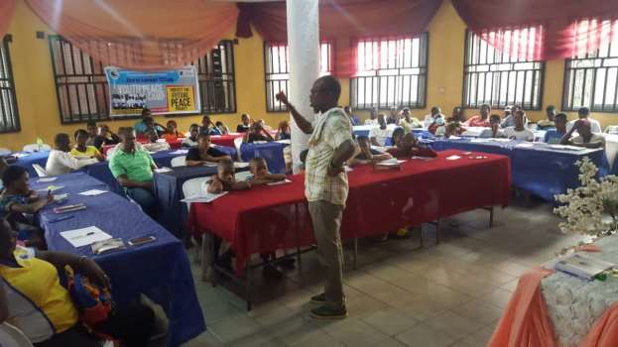
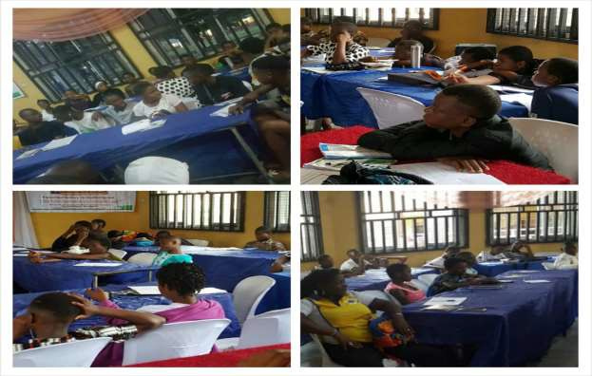

CROSS SECTION OF PARTICIPANTS AT THE 2022 PEACE CAMP LECTURES ONGOING

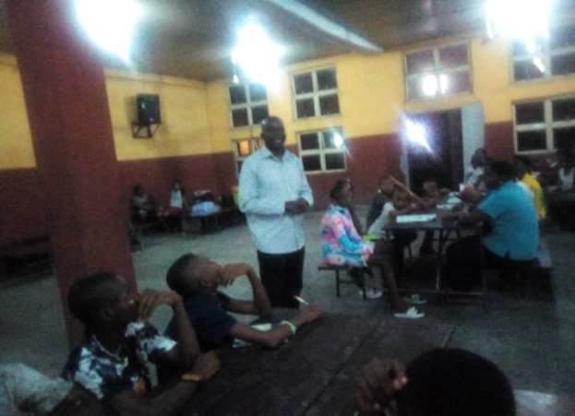
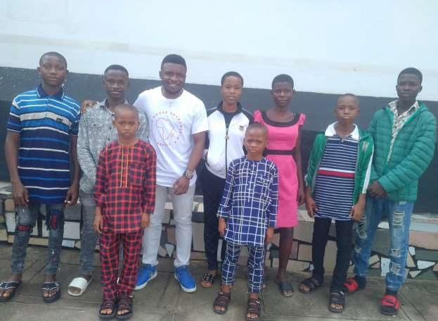
CROSS SECTION OF PARTICIPANTS AT THE 2022 PEACE CAMP LECTURES ONGOING
IMO PARTICIPANTS DURING THE DEPARTURE TO PORT HARCOURT WITH AFRIPEACE SUSTAINABLE DEVELOPMENT FOUNDATION PEACE CAMP COORDINATOR-IWUAMADI SUNDAY CHIMAOBI.

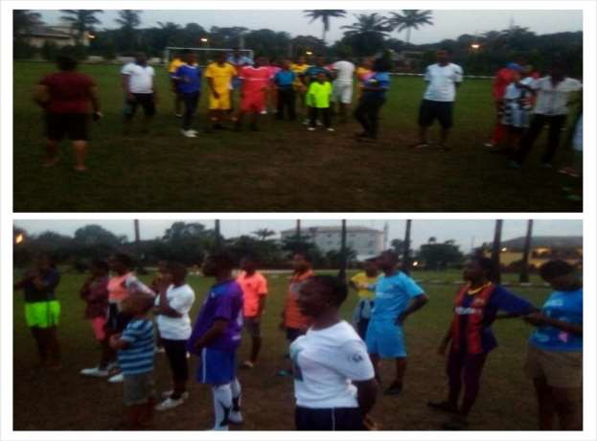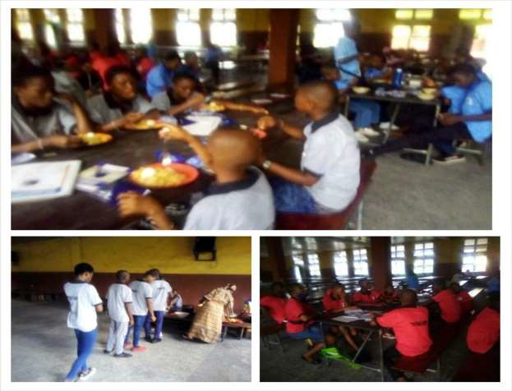

MORNING EXERCISE/ DEVOTION

PARTICIPANTS AT THE REFECTORY DURING THE 2022 PEACE CAMP

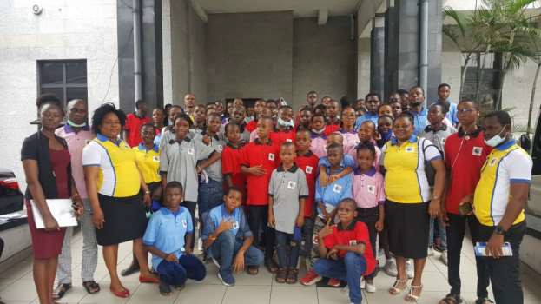
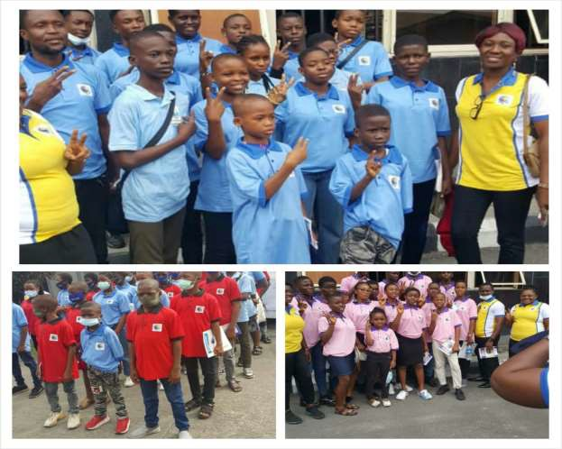

PARTICIPANTS AT THE 2022 PEACE CAMP DURING THE EXCURSION VISIT AT THE MAGISTRATE COURT

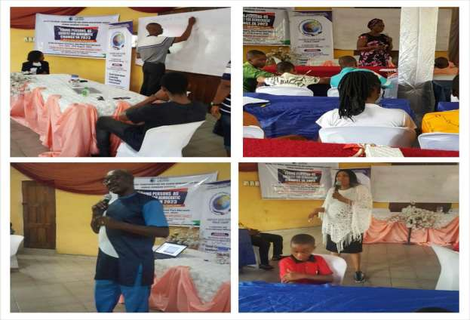

LECTURERS AND THE PARTICIPANTS DURING THE PEACE CAMP 2022
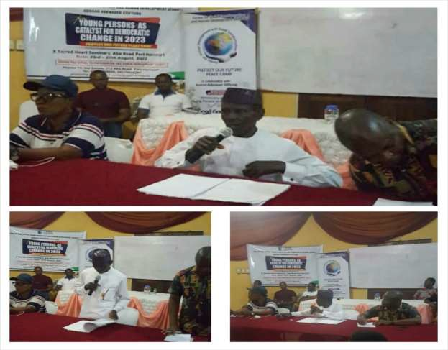
QUIZ COMPETITION SESSION AT THE 2022 PEACE CAMP

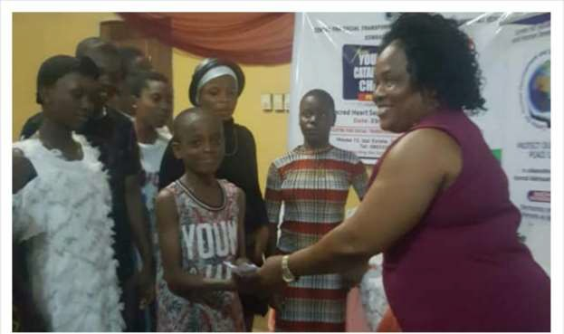

QUIZ COMPETITION PRIZE PRESENTATION

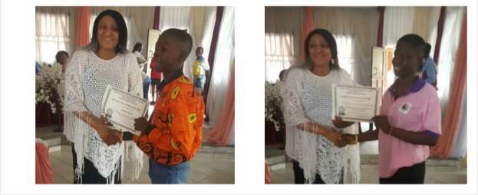

CERTIFICATE PRESENTATION TO PEACE CAMP 2022 PARTICIPANTS

Compiled and Edited by Iwuamadi Sunday Chimaobi
A.g Coordinator.

