2023

Nigeria Youth Peace Leadership Camp Report

Theme- Young Persons Believing in The Democratic Process.
Our Project-Future Peace
Venue: Sacred Heart Seminary, Artillery, Beside Ciwa Aba Road, Port Harcourt.
Date:7th-11th August 2023.

Edited by Iwuamadi Chimaobi Sunday
Ag. Coordinator

Afripeace Sustainable Development Foundation
12th August, 2023.

2023 NIGERIA YOUTH PEACE CAMP COMPLETION REPORT

IDENTIFYING INFORMATION
Project Title: Young Persons Believing in The Democratic Process

Type of Project: Education and Training

Project Proponent: Center for Social Transformation and Human
Development (CHDST) and Konrad Adenauer Stiftung in collaboration with Afripeace Sustainable Development Foundation.

Number of Beneficiaries: 8 Secondary Schools- 5(Rivers State) 2 (Imo State)
1(Bayelsa) 3 Staffs, 8 Teacher Coordinators and 46 Secondary School Students.

Program Supervisors: Rev Father Polycarp Henetu, Dr. Imoh Collins, Mrs
Chinelo, Iwuamadi Sunday Chimaobi

Speakers and Facilitators: Everest Nwakwo,Flora Asieri,Mrs Ege,Barrister
Nwanoke,Barrister Amadi .O. Amadi Nna,Barrister Obiareri N. Anugbum Esq., Mrs Ogbanga,

Place of Program Implementation: Sacred Heart Seminary,ArtilleryBeside
Ciwa,Aba Road,Port Harcourt.

Program Sponsors:
- Center for Social Transformation and Human Development (CHDST)
- Konrad Adenauer Stiftung
- Prof Ernest E. Uwazie Foundation
- Afripeace Sustainable Development Foundation.

EXECUTIVE SUMMARY
The Protect our Future Project which is a yearly camp program organized for Secondary schools with Peace clubs across the Niger Delta by Center for Social Transformation and Human Development (CHDST) was held for five days at Sacred Heart Seminary, Ciwa Aba Road, Port Harcourt from 7th – 11th August, 2023.
The camp brought members of peace clubs and students from Rivers, Imo state and Bayelsa to learn, be equipped and sensitized about Peace and Democracy with focus on Young Persons Believing in The Democratic Process. This was poised for a future with enlightened young persons in the country for a total change. It was an opportunity for students to ask question and get the right answers with guidance on the right thing to do.

Theme of interaction Young Persons Believing in The Democratic Process stirred up the student’s zeal to become agents of change in the society. It featured topics such as understanding democracy and how it works, Going the extra mile to facilitate a change in 2023, Sustainable development goals (SDG), Creating awareness on human trafficking, young person’s sustaining democratic change, Court and its application, Creating a new reality and No to all forms of vices to our progress.

The resource persons cut across various fields from Lecturers, management consultants, Doctors and peace practitioners and lawyers. They drew from their wealth of experience to present an educative, interactive and motivating peace camp. There were opportunities for outdoor events and the students had the unique experience of visiting the High Court. The excursion visit exposed the students the dynamics of democracy in action as regards to the law. Students were privileged to interact with the lawyers, document their finding after the court process, had site seeing and were provide with answer to the questions asked. General group works during the camp lectures that developed their skill of intellectual thinking.

The strategic session of the peace camp was used as an avenue to plan for the expansion of peace clubs. The youth Peace camp participants were supplied with writing materials, daily feeding (breakfast/lunch and dinner) and T-Shirts for Identification.

The total number of participants for the camp were 57.

HIGHLIGHTS FOR THE 2023 PEACE CAMP DAY 1
Opening: An opening prayer was said by Mrs. Chinelo a teacher coordinator who is an active coordinator of the peace camp organized by Center for Social Transformation and Human Development (CHDST).

Arrival/Registration: The students were registered by the Center for Social Transformation and Human Development (CHDST).

Ground Rules: The camp rules and regulation that will be governing the camp was read to the hearing of all the students and they were advised to ensure total compliance to it. Students were advised to conduct themselves in an orderly manner and observed all the lecture and boarding protocols.

Briefing of Participants: Dr Imoh on behalf of the executive director welcomed the participant to the 2023 camp meeting both students and teacher coordinators from the different states. He appreciated their efforts so far with the view of cultivated peace building and active participation in it. The camp is well defined with an important theme- Young Persons Believing in The Democratic Process. Everyone role is important as it’s a team spirit involvement and an ideology of building a society where young persons have capacity and intellect for democracy success. Let’s position our minds and conscience to learn participate and be developed. Be of good behavior and ensure you go home renewed with the knowledge you will grasp.

Group Sharing: The students were divided into four groups and teacher coordinators were attached to coordinate the activities of each of the group.

The groups:
- Progress
- Love
- Progress
- Unity
The groups are to perform their different functions for the effective running of the peace camp. Different groups will be responsible for cleaning the boarding rooms, Lecture Hall, washing of the bathrooms, the toilets daily and more importantly team representation on the grand finale to compete across the variety activities- (Drama, Song and Dance).

LECTURES

During this session students were charged to be all seated and pay absolute attention.
- Drug Abuse
Drug abuse have remained a key factor for health degradation and is known to be a method of overdosing drug against the doctor’s prescription. In other words, intake of hard drugs is also the major drive of drug abuse. Examples of hard drugs: Cocaine, Indian hemps and methamphetamine. The consequences of taking hard drugs, common cause of hard drugs, remedies and advice. This information’s were detailed explicitly for the students.

DAY 2
All early morning activities as to exercise, morning devotion and clean-up of the boarding facility were carried out by the students with supervision of the teacher coordinators. After which all students and participants assemble for breakfast and then back to the lecture hall for the day’s activities.

Lectures;
- Young Persons Believing in the Democratic Process by the CHDST team: This served as the entrance of the peace camp as regards to the general theme. Here the highlights of the sponsors and co-sponsor were shared with the participant detailing to all the mission and vision of the organization and the intended goal to be achieved. The goal as structured is for young persons to become agent of change via good governance, leadership, environment and peace building & conflict transformation in the community.

OFF ELECTORAL OFFENCES by Everest Nwankwo:
This session of the lecture captured off electoral offences as in scripted in the part 8 of the law of constitution. These section offences were listed for the students to grasp. Breakdown of how this laws function during election, post-election, punishment under the offences, preventing someone from registering and ballot snatching were all given and participants were provided with answers to their questions.

- PEACE AND CIVIC EDUCATION by Flora Asieri: Peace education is the building process of peace that teaches us how to settle differences in a non-violence manner. It involves building transferable skills, knowledge, attributes and behaviors. Peace education programs are centered on democracy education focused on the political processes associated with conflict. In this context, the Nigeria scenario was given to
the participants as regards to the just concluded election following these questions?

  - How are elections conducted?
  - What is the process like?
  - Are elections free and fair?
  - Are elections violence free?
This triggered several responses which articulated more learns. Furtherance the different abbreviations tied to the election and its process were defined.
    - INEC: Independent National Electoral Commission.
    - BVAS: Bimodal Voters Accreditation System.
    - IREV: INEC Result Viewing Portal
Also, civic education was explained as participants were made to know their civic rights and engagements.

DAY 3
All early morning activities as to exercise, morning devotion and clean-up of the boarding facility were carried out by the students with supervision of the teacher coordinators. After which all students and participants assemble for breakfast and then back to the lecture hall for the day’s activities.

Lectures;
- ACTIVE PARTICIPATION IN THE DECISION-MAKING PROCESS by Mrs. Ego
Participants were educated on need to participate in the decision making of our democracy. Breakdown the requirements for young person’s believing and participating in democratic process, obstacles that exist, recognition of rights to participate, need for participation in political activities, structures to identify and strategies to use.

YOUTH DEMOCRACY AND PEACE-Mr. Barrister Nwanoke
During this sessions students/participant were meant to know their different capacity and roles as to taking charge.

DAY4
All early morning activities as to exercise, morning devotion and clean-up of the boarding facility were carried out by the students with supervision of the teacher coordinators. After which all students and participants assemble for breakfast and then back to the lecture hall for the day’s activities.

EXCURSION DAY

Visit to Magistrate Court
This was an opportunity for outdoor activity to learn and have site seeing. The students had a unique experience visiting the Magistrate Court. The excursion visit exposed the students to the dynamics of democracy and the law in action. Students were privileged to interact with the lawyers, had site seeing around the court to the conference hall, internet/strong room(server) correctional cell, etc. The also took note of the observation and as well documented them in the court document book. Participants were provided with answer to the questions they asked. Barrister. Mr. Amadi. O. Amadi Nna and Barrister. Mrs. Obiageri N. Anugbum Esq were they barrister in charge of the two court sittings.

After the court excursion all road lead back to the camp for the other lecture sessions. Lectures continues;
SUSTAINABLE DEVELOPMENT GOALS by Doctor Mrs. Ogbanga
- Participants were made to know that the SDG means Sustainable Development Goals which is the framework for development and planning in the society and was adapted in 2015. SDGs was put in place to address the problems of the common people and to improve the quality life of citizens. There are 17 SDGs as follows; Poverty, Zero Hunger, Health & well-being, quality education, quality gender, clean water & sanitation, renewable energy, good job &economic growth, innovation, infrastructure and industry, reduced inequalities across countries, sustainable cities and communities, responsible consumption, protect the planet (climate action), life below water, life on land, peaceful & inclusive society and partnership for the goals.

VARIETY NIGHT
This is usually a closeout program for fun and lots of recreational and academic activities are involved. This time, there were drama, Song, personal and comedy presentations focusing on peaceful co-existence. Participants represented their various groups as shared in the camp as follows;(Peace,Unity,Progress and Democracy).According to the different groups,they made their presentation as each group had their delegates for each activity. These groups were made up of 10-13 members including a teacher coordinator. The program featured 7 exciting activities. Performances were record and results also given accordingly.

Result of Variety Night Drama-Peace-Winners Dance-Peace- Winners
Song-Progress and Unity- Winners

DAY 4 – (Last Day)
Indeed, a great camp outing as all participants were happy to have taken part in it. As usual, the last day of the camp is here and participants who came from different parts of the country will be travelling back to their destinations. As it is structured in the program plan, it is a norm on the last that these following activities are carried out as follows; Student’s acknowledgement, certificate presentation and the word for the road.

PRESENTATION OF CERTIFICATE
Certificate of participation was given to the participants (students only) and was presented by Dr Imoh of Centre for Social Transformation and Human Development, some facilitators and Mrs. Chinelo.

- Evaluation: All students submitted a written one page note of their experience in the camp with what they have learnt. This session was carried out to ascertain the impact the camp has had on the student participants.
- Peace Camp Experience report by all students

Closing remark
The organizer, Center for Social Transformation and Human Development (CHDST) appreciated and encouraged all the students to put in their best to ensuring active engagement in academic studies as well as ensuring they develop their talent and basic skills. However, referencing the theme: Young Persons Believing in The Democratic Process. They were advised to continue as agents of change and always stand up for the right.
Keep sustenance the momentum on peace building in the society especially within their school and peers, grow their school peace clubs.

RECOMMENDATIONS
- Peace Education should be included in the school curriculum.
- More schools in the state should participate in the Annual Peace Camp programs
- Boarding and hosting the students in a place is still the best.

FINANCIAL REPORT
Afripeace Sustainable Development Foundation registered 8 students and teacher coordinators into the 2022 peace camp and sponsored their travels alongside 1 BOT members.

PEACE CAMP 2023 INCOME AND EXPENSE
Expenses

S/N | DESCRIPTION | NUMBER OF  PERSONS | RATE | TOTAL AMOUNT
1 | 2022 IMO STATE PEACE CAMP  REGISTRATION | 8 | N23,125 | N185,000
2 | TRANSPORT TO AND FRO TO PORT  HACOURT AND OWERRI | 8 | N7,000 | N56,000
3 | LOCAL TRANSPORTATION IN PORT HARCOURT | 8 | N600 | N4,800
4 | TEACHER COORDINATORS ALLOWANCE | 1 | N10,000 | N10,000
5 | TRANSPORT TO AND FRO TO PORT HACOURT AND OWERRI FOR IWUAMADI  SUNDAY | 1 | N3,500 | N7,000
6 | ALLOWANCE FOR IWUAMADI SUNDAY  (Coordinator ASDF Nigeria) | 1 | N5,000 | N5,000
TOTAL |  |  |  | N267,800

TOTAL INCOME= N257,300+10,500=N267,800. TOTAL EXPENSES= N267,800

Students Registration
Each student paid a sum of N1,500 to register for the 2023 peace camp. A total of 7 students registered through Afripeace Sustainable Development Foundation. Sum=N10,500.
Total Sum Received- N257,300+10,500=N267,800.

EXPENSES
The sum of hundred thousand naira(N185,000) only was paid to Center for Social Transformation and Human Development for co-sponsorship of the 2023 peace camp in Rivers State.

Transportation to and Fro Rivers State- N63,000 Local Transport in Rivers State -N4,800 Reporting and editing –N5,000

Teachers Allowance - N10,000
- Mrs. M.C Uwah- N10,000

Afripeace Sustainable Development Foundation Representative allowance/stipends-
N5,000.
- Ms. Iwuamadi C. Sunday- N5,000

Total Expenses- N272,800

NAMES OF IMO PARTICIPANTS

Afripeace Sustainable Development Foundation Rep
1.Iwuamadi Sunday Chimaobi

Teacher Coordinators
1.Mrs Martha Uwa, C

Students and Schoools

COMPREHENSIVE SECONDARY SCHOOL UMUEZEALAOGWARA
- Ohaekelem Maryjane
- Onyebelem Alin
- Daniel Maryann
- Nwaluka Favour
- Uche Chinemerem
- Chinedu Rosemary
- Desmond Chidinma

PICTURE GALLERY
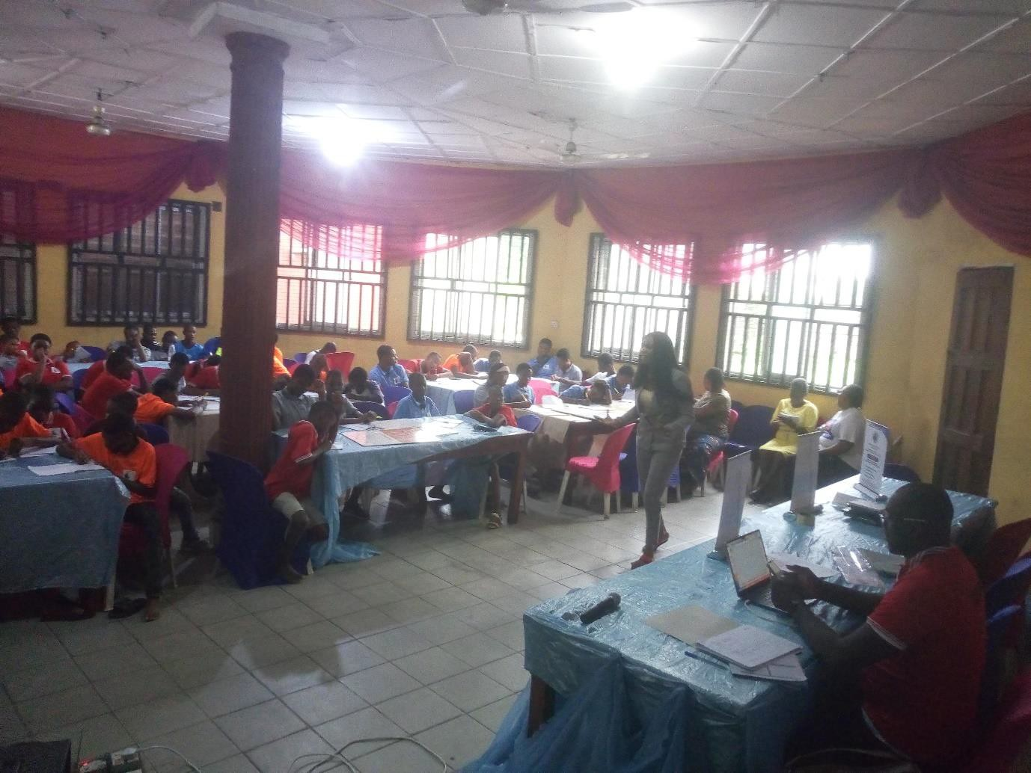
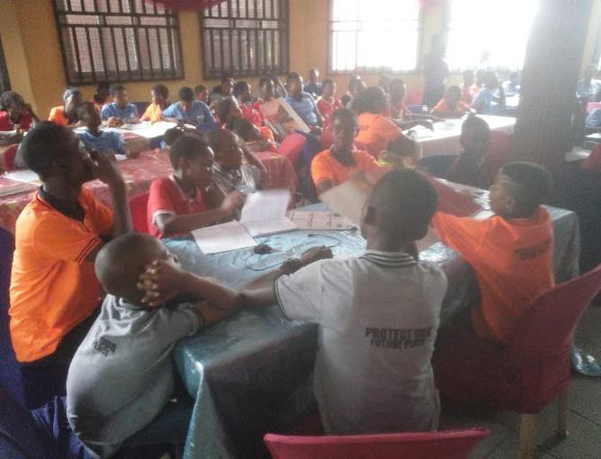
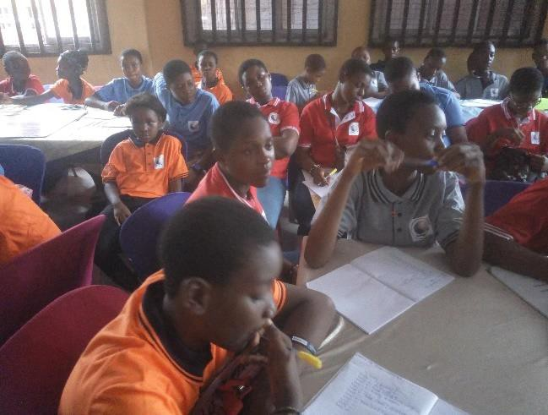
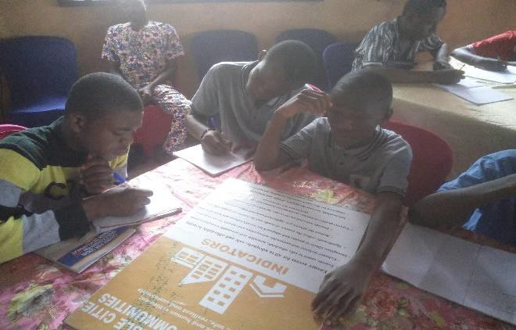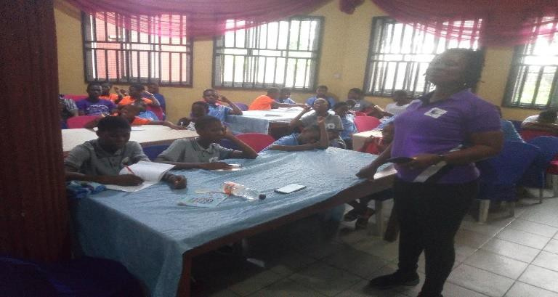

CROSS SECTION OF PARTICIPANTS AT THE 2023 PEACE CAMP LECTURES ONGOING

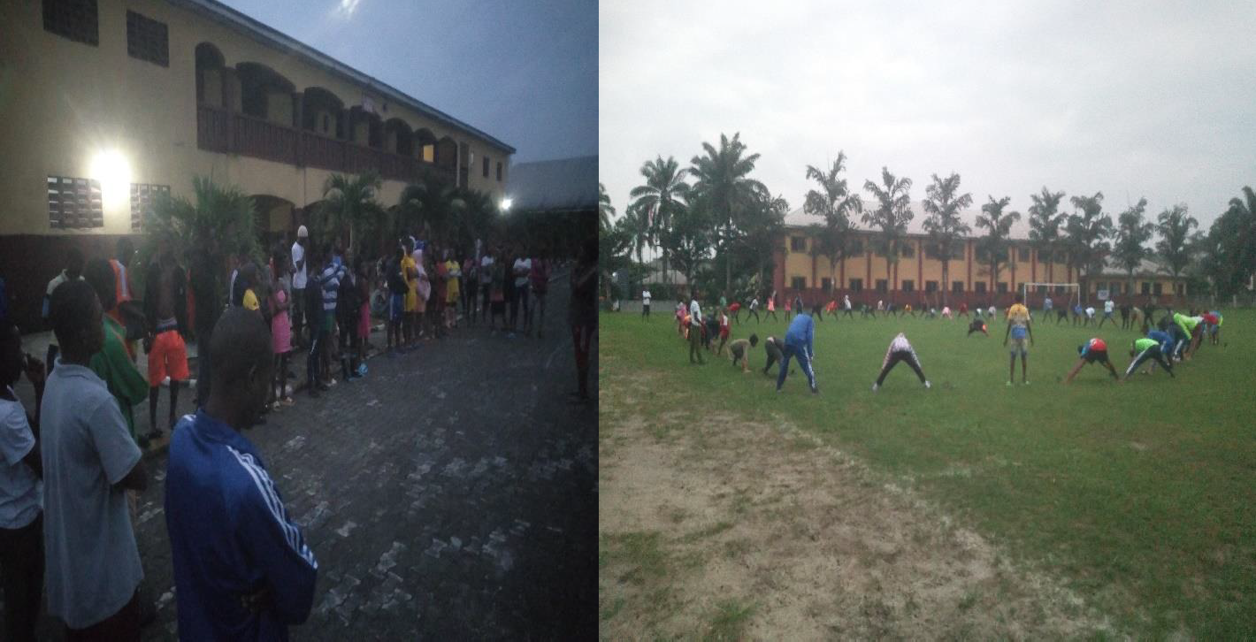

MORNING EXERCISE/ DEVOTION
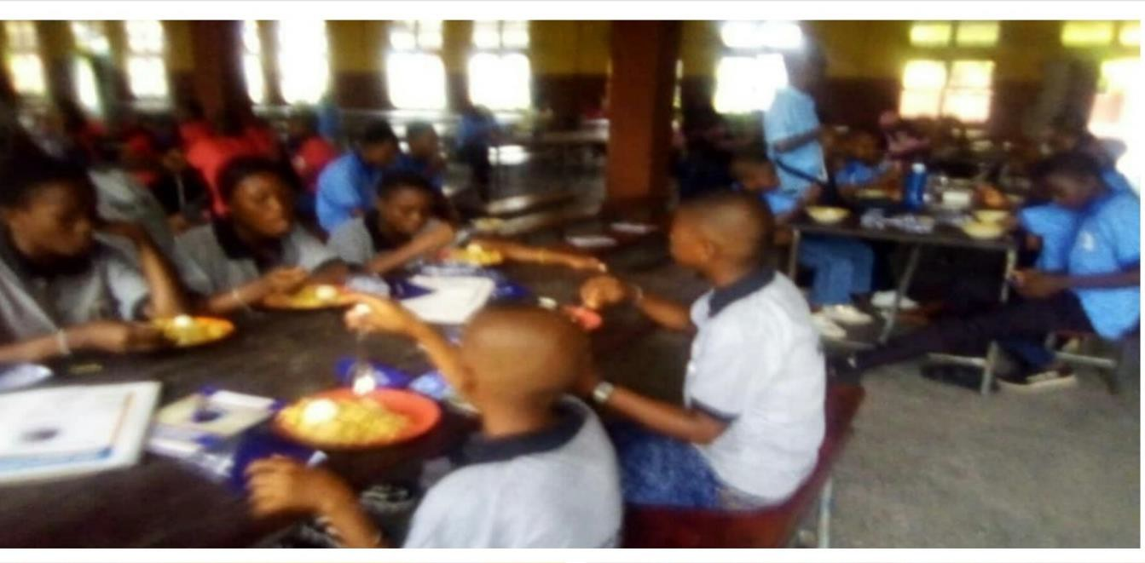
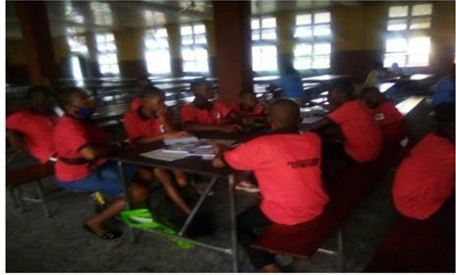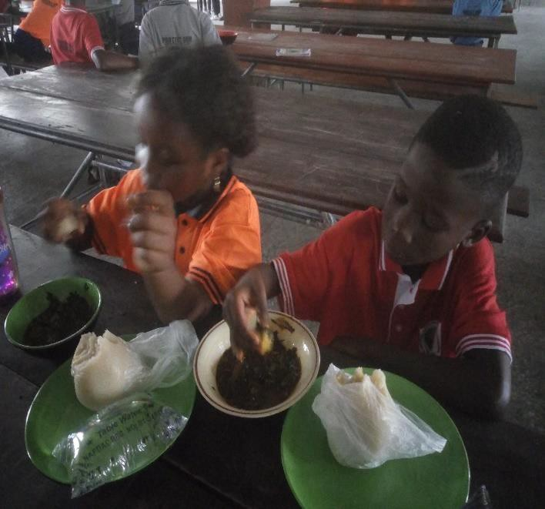

PARTICIPANT AT THE REFECTORY DURING THE 2023 PEACE CAMP

PICTURES FROM THE EXCURSION VISIT TO RIVERS STATE HIGHT COURT
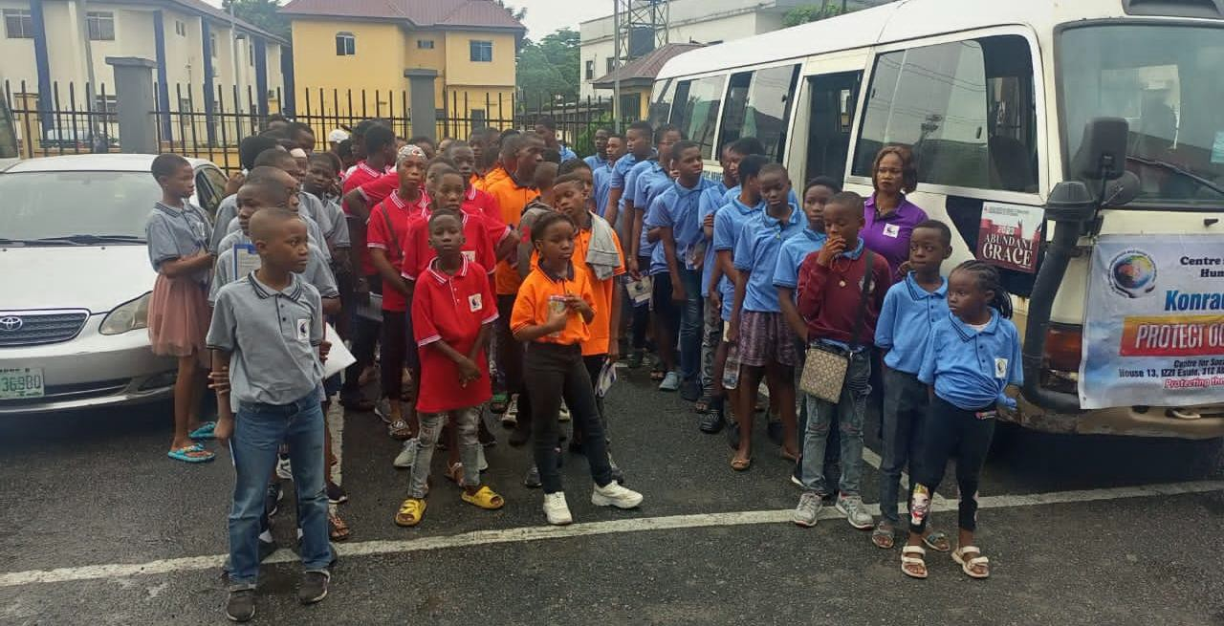
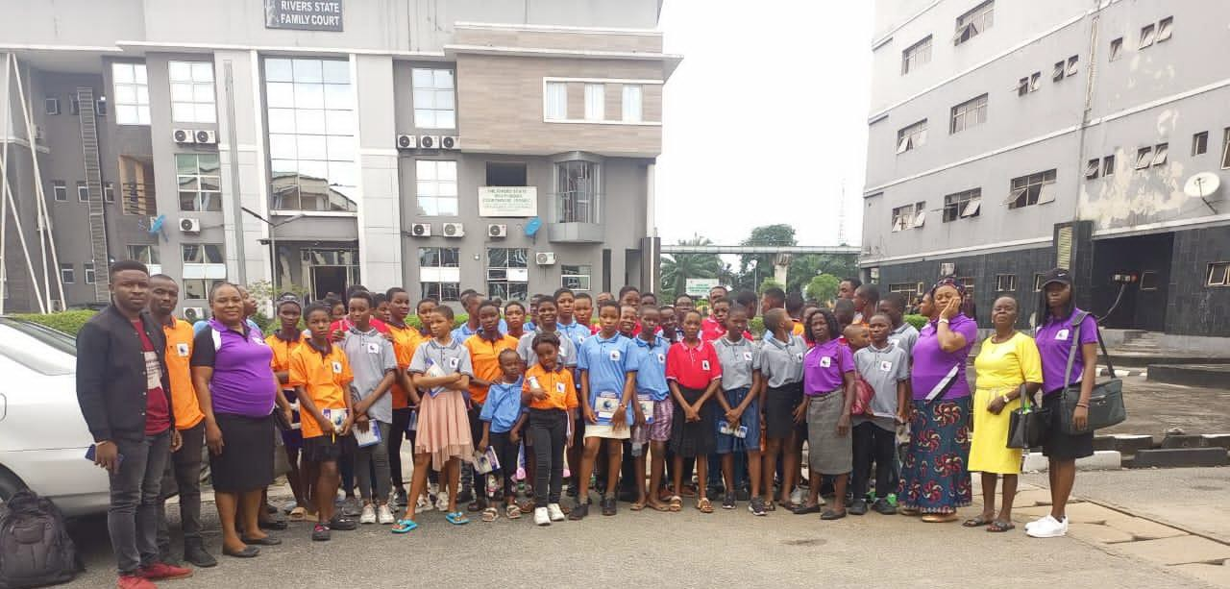
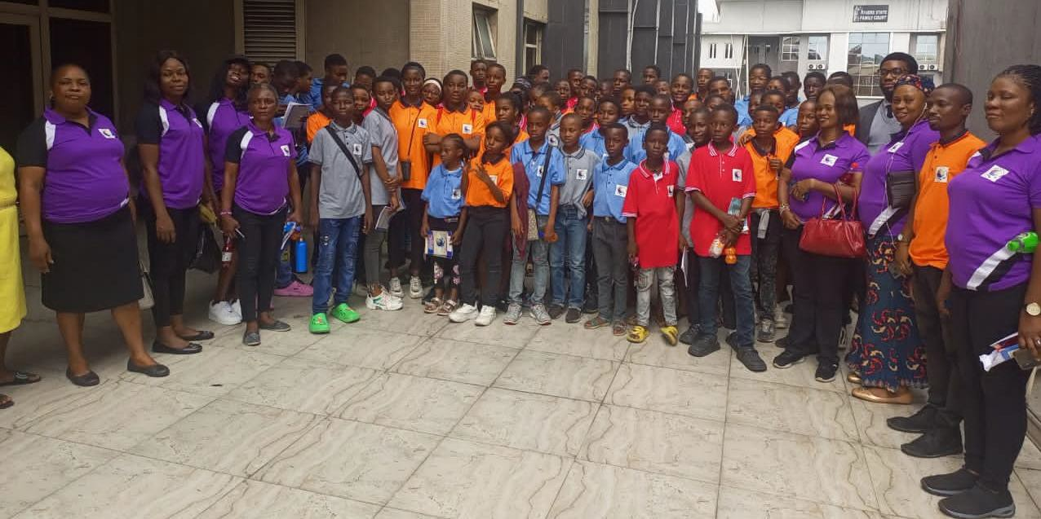

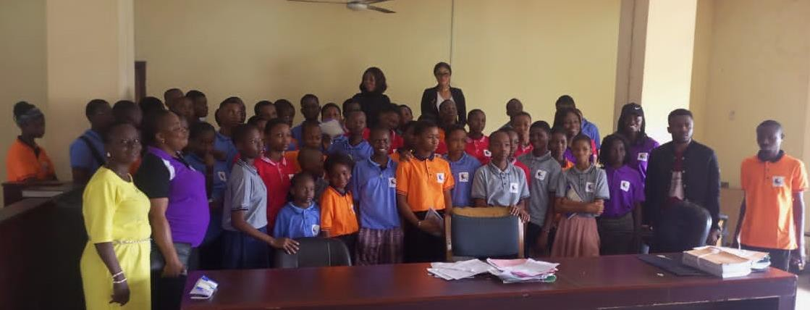
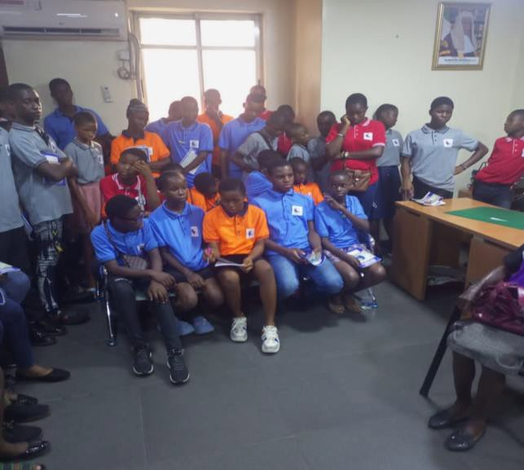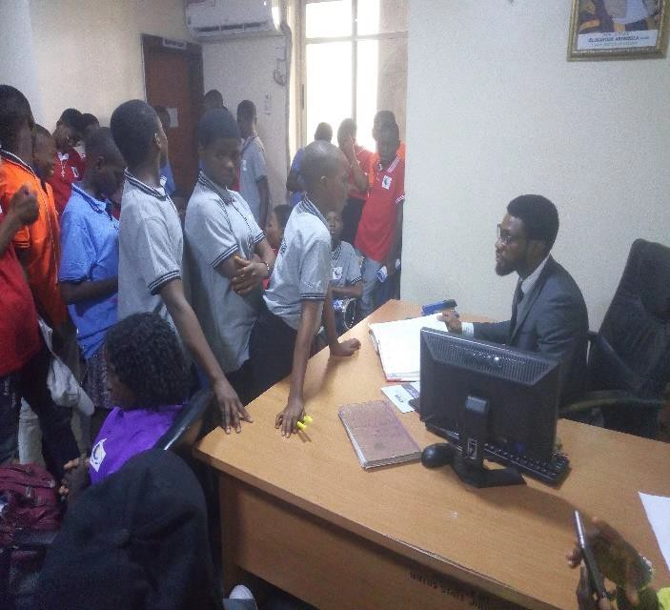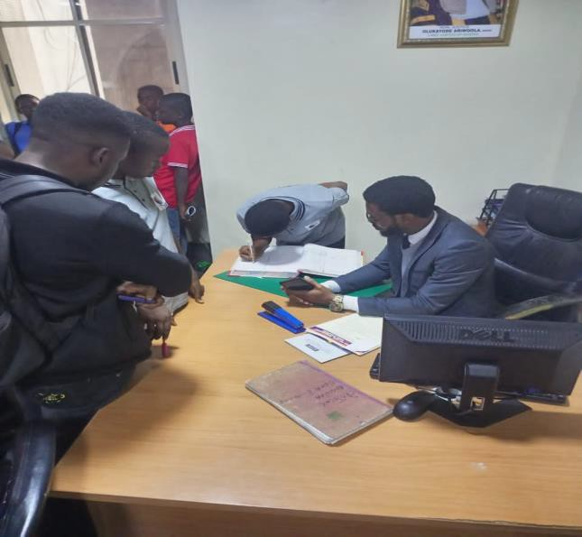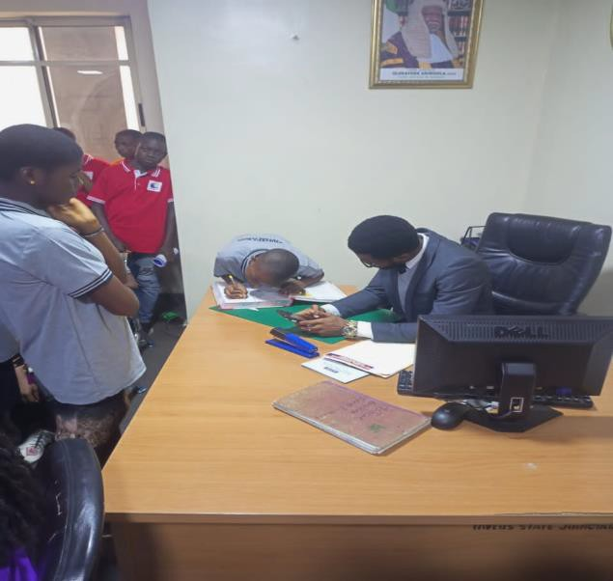
GROUP PICTURE WITH THE COURT MAGISTRATES
DOCUMENTATION OF OBSERVATIONS, INFORMATIONS AND KNOWLEDGE GAINED FROM THE COURT SITTINGS BY PARTICIPANTS

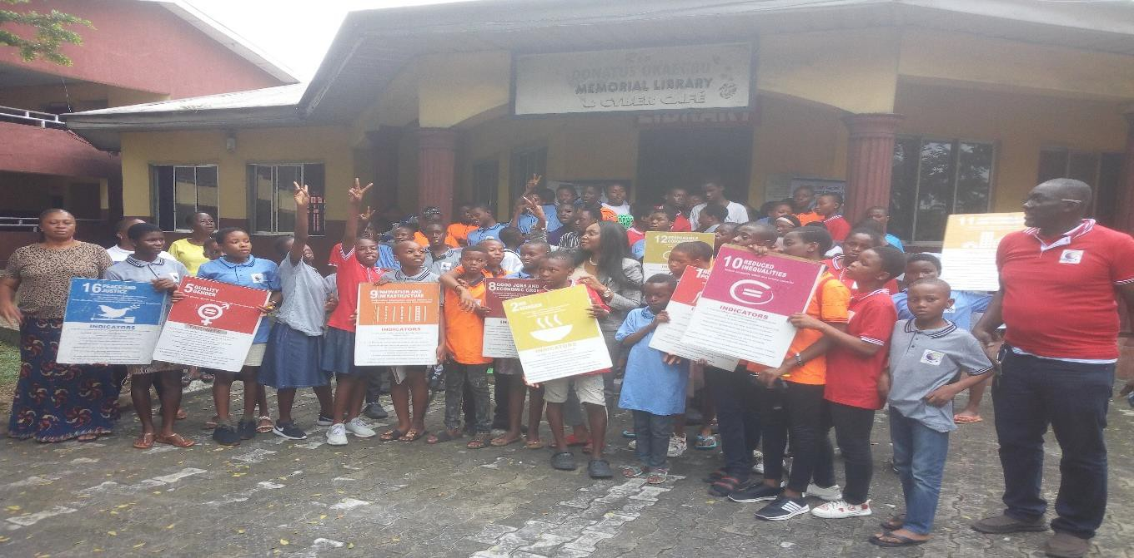
PARTICIPANTS DISPLAYING THE PLAYCARDS IMMEDIATELY AFTER SUSTAINABLE DEVELOPMENT
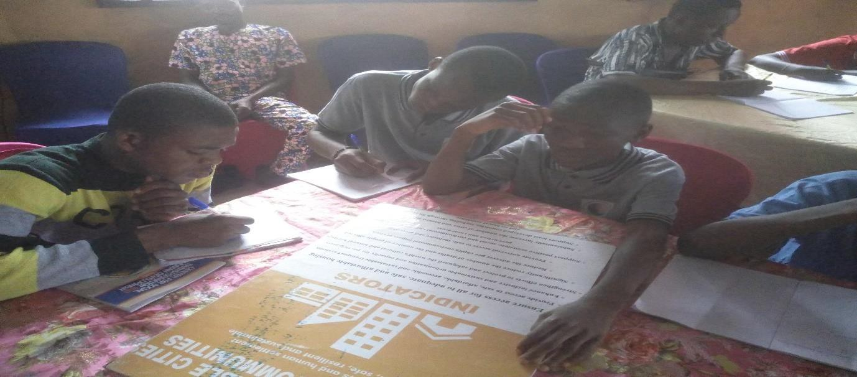

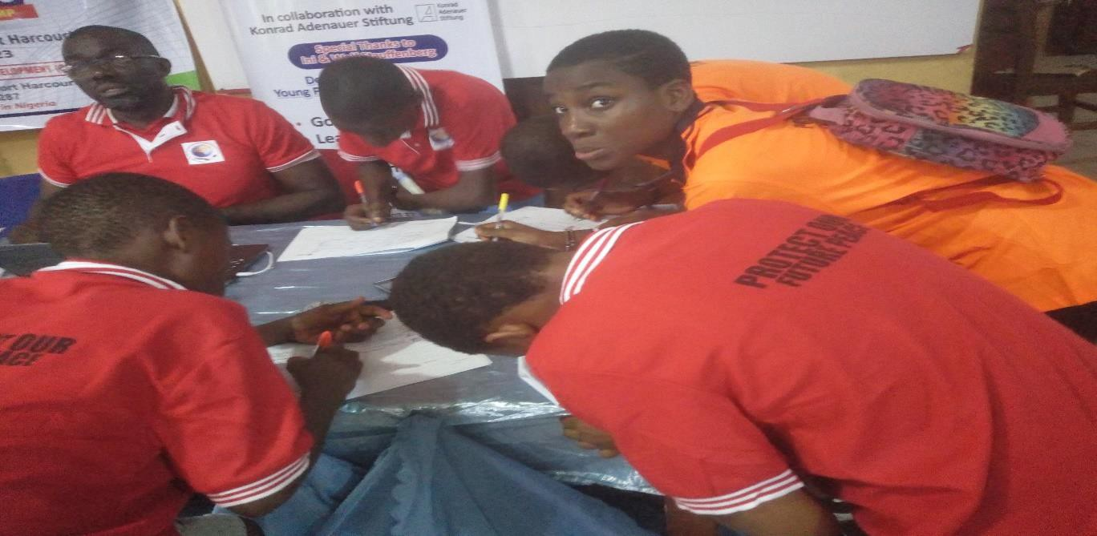
PARTICIPANTS WRITING AND SIGNING THEIR ATTENDANCE

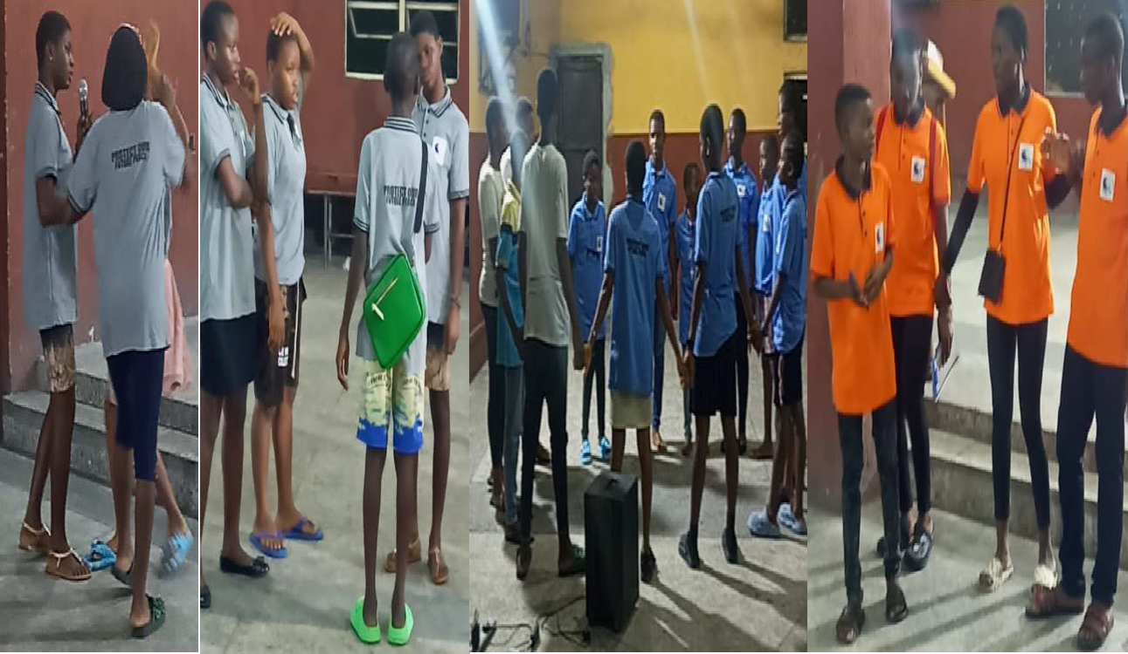
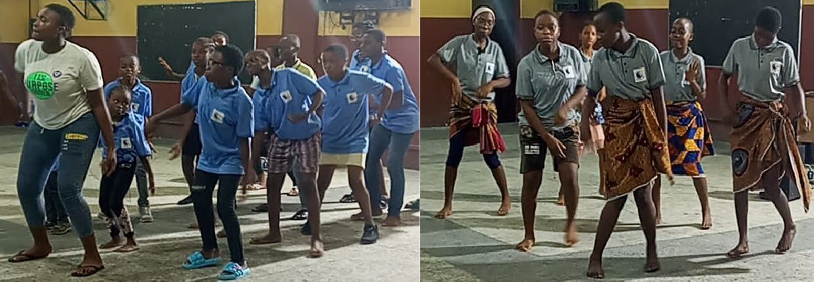
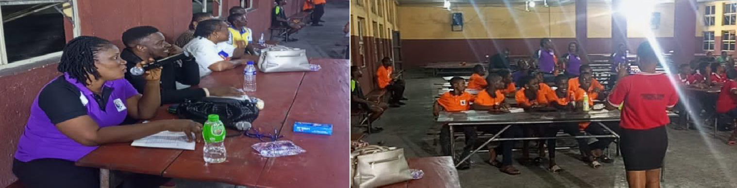
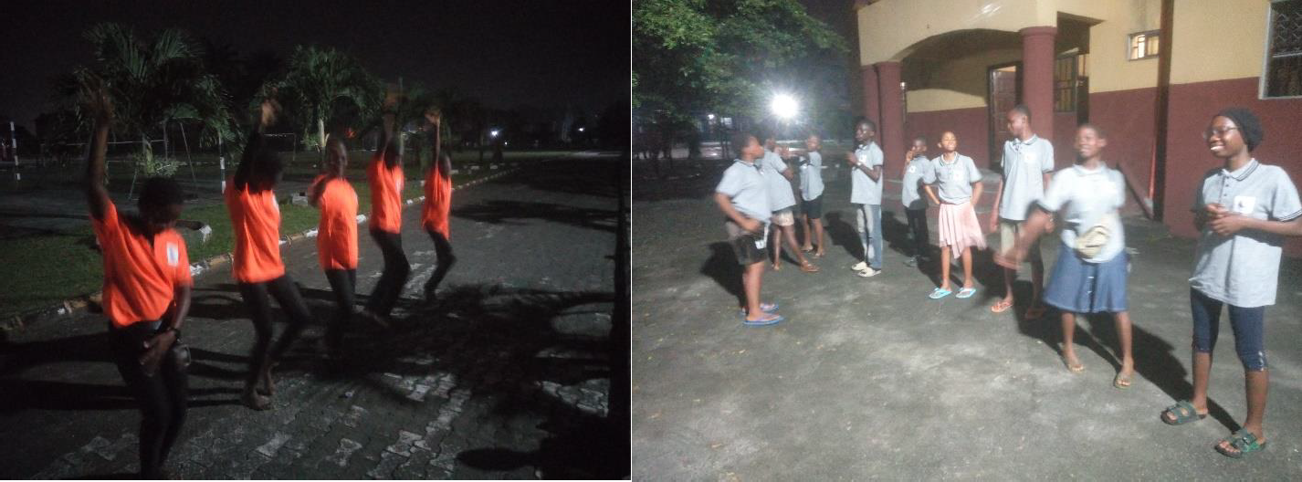
REHEARSALS FOR VARIETY NIGHT
VARIETY NIGHT ACTIVITIES-DANCE, DRAMA, PERSONAL PRESENTATIONS AND SONGS

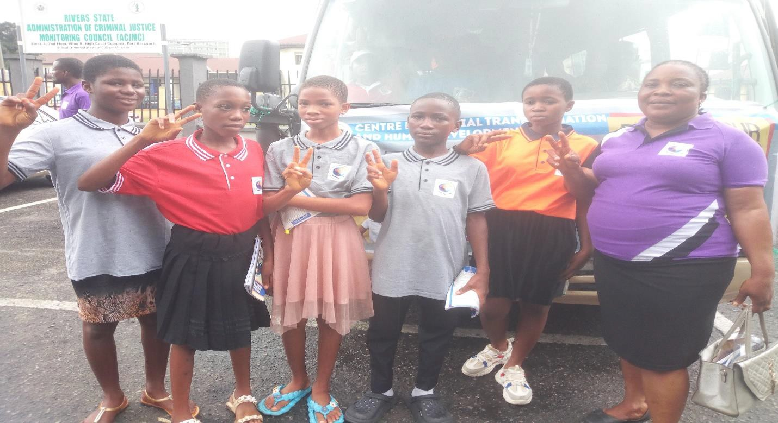
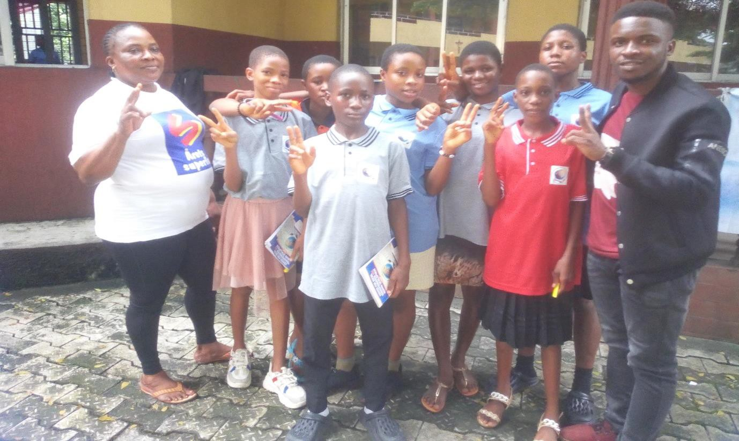

IMO PARTICIPANTS AT THE 2023 PEACE CAMP PORT HARCOURT WITH AFRIPEACE SUSTAINABLE DEVELOPMENT FOUNDATION PEACE CAMP COORDINATOR-IWUAMADI SUNDAY CHIMAOBI.

Compiled and Edited by: Iwuamadi Sunday Chimaobi
A.g Coordinator.

