2024

Nigeria Youth Peace Leadership Camp Report

Theme- Young Persons Believing in The Democratic Process.
Our Project-Future Peace
Venue: Sacred Heart Seminary, Artillery, Beside Ciwa Aba Road, Port Harcourt.
Date:5th-9th August 2024.

Edited by Iwuamadi Chimaobi Sunday Ag. Coordinator
Afripeace Sustainable Development Foundation 12th August, 2024.

2024 NIGERIA YOUTH PEACE CAMP COMPLETION REPORT IDENTIFYING INFORMATION
Project Title: Young Persons Believing in The Democratic Process to Sustain the Economy.
Type of Project: Education and Training
Project Proponent: Center for Social Transformation and Human Development (CHDST) and Konrad Adenauer
Stiftung in collaboration with Afripeace Sustainable Development Foundation.
Number of Beneficiaries: 8 Secondary Schools- 6(Rivers State) 3 (Imo State) 3
Staffs, 8 Teacher Coordinators and 75 participants.
Program Supervisors: Rev Father Polycarp Henetu, Dr. Imoh Collins, Louis Ogu, Iwuamadi Sunday Chimaobi
Speakers and Facilitators: Barr. Bestman Nwoke, Flora Asieri, Prince Uwaifo
Obiawe, Prof Nnamdi Anelo, Mrs. Chinwe Saware, Dr. Mrs. Peter Rita, Mr. Amadi Nnamdi Awale, Prof. Ernest Uwazie, Everest Nwakwo.
Place of Program Implementation: Sacred Heart Seminary,Artillery Beside
Ciwa,Aba Road,Port Harcourt.

Program Sponsors:
- Center for Social Transformation and Human Development (CHDST)
- Konrad Adenauer Stiftung
- Prof Ernest E. Uwazie Foundation
- Afripeace Sustainable Development Foundation.

Executive Summary: Young Persons Believing in The Democratic Process Overview
The Young Persons Believing in The Democratic Process peace camp, a component of the annual Protect our Future project organized for Secondary schools with Peace clubs across the Niger Delta by Center for Social Transformation and Human Development (CHDST) and Afripeace sustainable development foundation which is aimed to empower secondary school students
with knowledge and skills to actively participate in democratic processes. Held at Sacred Heart Seminary, Port Harcourt, the five-day camp provided a platform for students to engage with experts on topics such as democracy, communication skills, leadership, youth participation, human rights, and the electoral process." This initiative brought together 70 students from Imo,
Delta, and Bayelsa States to foster a deeper understanding of democratic principles and civic engagement.

Key Objectives
  - To equip young people with the knowledge and skills necessary to participate effectively in democratic processes.
  - To cultivate a culture of peace, tolerance, and respect among diverse groups of young people.
  - To inspire young people to become active agents of positive change in their communities.

Program Highlights
The camp featured a diverse range of topics delivered by expert lecturers:
  - Democratic Principles and Processes: Participants gained insights into the foundations of democracy, including voting rights, freedom of speech, and the role of civil society.
  - Communication Skills: Effective communication techniques were taught to enhance interpersonal relationships and public speaking abilities.
  - Leadership and Governance: Participants learned about leadership styles, decision- making processes, and the importance of ethical governance.
  - Economic and Social Issues: Discussions focused on the impact of youth participation on economic development and social justice.
  - Legal and Human Rights: Participants gained knowledge of legal frameworks, human rights, and the role of the judiciary.

  - International Education: Information was provided about studying abroad, particularly in the United States.

Impact and Outcomes
The camp successfully achieved its objectives by:
  - Knowledge and Skill Development: Participants gained a comprehensive understanding of democratic principles and practical skills for civic engagement.
  - Interpersonal Skills: The camp fostered positive relationships among participants from diverse backgrounds, promoting tolerance and understanding.
  - Leadership Empowerment: Participants developed leadership skills and a sense of responsibility to contribute to their communities.
  - Inspired Civic Engagement: The camp ignited a passion for civic engagement and a desire to make a positive impact.

Practical Workshops

Participants actively engaged in workshops designed to enhance their decision-making abilities, critical thinking skills, and problem-solving techniques.

Accommodation and Logistics
The camp provided comfortable accommodation, nutritious meals (breakfast and dinner), and essential writing materials. Additionally, participants received branded T-shirts.

Conclusion
The "Young Persons Believing in The Democratic Process" peace camp was a transformative experience that empowered young people to become active and informed citizens. By providing a platform for learning, discussion, and networking, the camp has laid the foundation for a more engaged and democratic future.

HIGHLIGHTS FOR THE 2024 PEACE CAMP

Day 1

  - Opening Ceremony: The camp began with a prayer led CHDST staff, a key organizer from the Center for Social Transformation and Human Development (CHDST).
  - Registration: Students were registered by CHDST/ASDF staff.
  - Ground Rules: Camp rules and regulations were explained to the students, emphasizing the importance of orderly behavior and adherence to the camp's protocols.
  - Welcome Address: Dr. Imoh, on behalf of the executive director, welcomed the students and teacher coordinators from various states. He highlighted the theme of the camp, "Young Persons Believing in The Democratic Process," and encouraged active participation and teamwork.
  - Group Formation: Students were divided into four groups: Progress, Love, Progress, and Unity. Each group was assigned a teacher coordinator and given specific responsibilities, including cleaning duties and preparing for the grand finale performances.

LECTURES
During this session students were charged to be all seated and pay absolute attention.

Part 1: Understanding Human Rights
- Fundamental Human Rights

  - What are human rights?
    - Basic rights and freedoms that belong to every person from birth until death.
  - Why are human rights important?
    - They protect our dignity and worth.
    - They ensure we can live free from fear and want.
  - Examples of fundamental human rights:
    - Right to life, liberty, and security of person
    - Freedom of thought, conscience, and religion
    - Freedom of expression and opinion
    - Right to education
    - Right to work and fair wages

Principles of Human Rights

  - Universality: Human rights apply to everyone, regardless of race, sex, nationality, ethnicity, language, religion, or any other status.
  - Inalienability: Human rights cannot be taken away.
  - Indivisibility and interdependence: All human rights are equally important and cannot be separated.

Types of Human Rights

  - Civil and political rights: Protect individual freedoms, such as the right to vote, freedom of speech, and the right to a fair trial.
  - Economic, social, and cultural rights: Ensure social and economic well-being, such as the right to work, education, and healthcare.

Part 2: Electing Good Leaders in Nigeria
- A Politician

Definition: A person active in party politics.

  - Qualities of a good leader:
    - Honesty and integrity
    - Strong moral character
    - Empathy and compassion
    - Effective communication skills
    - Visionary thinking
    - Strong leadership skills
    - Dedication to public service

Problems in Politics

  - Corruption: Misuse of public funds for personal gain.
  - Nepotism: Favoritism shown to family or friends, especially by those in power.
  - Electoral malpractice: Rigging elections, voter intimidation, and other dishonest practices.
  - Poor governance: Ineffective and inefficient government.

DAY 2

Cultivating a Culture of Peace
- What is a culture of peace?
  - A culture of peace is a set of values, attitudes, and behaviors that reject violence and promote peaceful conflict resolution.
  - It emphasizes understanding, tolerance, and cooperation.

How to cultivate a culture of peace:
  - Education: Teach people about peace, human rights, and conflict resolution.
  - Communication: Encourage open and honest dialogue.
  - Tolerance: Respect and appreciate diversity.

  - Empathy: Understand the feelings and perspectives of others.
  - Non-violence: Resolve conflicts peacefully.
  - Cooperation: Work together to achieve common goals.
  - Social responsibility: Be aware of your impact on others and the environment.
  - Community engagement: Participate in community activities and volunteer work.

Oil-Rich Regions of the Niger Delta
1. Key Oil-Producing States:
- Delta State: Known for its extensive oil fields and numerous oil companies.
- Rivers State: Home to Port Harcourt, a major oil hub in Nigeria.
- Bayelsa State: Rich in oil and gas resources, with a significant impact on the Nigerian economy.
- Akwa Ibom State: A major oil-producing state with significant oil and gas infrastructure.
- Imo State: Although not as prominent as the others, Imo State has some oil and gas resources.

Activity Ideas:
- Role-playing: Act out scenarios involving conflict resolution, intercultural dialogue, or community service.
- Group discussions: Debate topics like "The importance of peace in society" or "The impact of oil on the Niger Delta."
- Creative writing: Write poems, songs, or short stories about peace, culture, or environmental issues.
- Art and crafts: Create artwork that reflects the themes of peace, culture, and environmental sustainability.
- Field trips: Visit local communities, cultural sites, or environmental organizations.

DAY 3

Communication Skills
- Importance of Effective Communication:
  - Building relationships
  - Resolving conflicts

  - Achieving goals

Verbal Communication:
  - Active listening
  - Clear and concise speech
  - Public speaking

Non-verbal Communication:
  - Body language
  - Facial expressions
  - Eye contact

Written Communication:
  - Essay writing
  - Report writing
  - Letter writing

Interpersonal Communication:
  - Assertiveness
  - Empathy
  - Negotiation

Youth Democratic Participation and Economic Resuscitation
- Understanding Democracy:
  - Definition and principles
  - Role of citizens in a democracy

Youth as Agents of Change:
  - The power of young voices
  - Engaging in political processes
  - Volunteering and community service

Economic Implications of Youth Participation:
  - Innovation and entrepreneurship

  - Social and economic development
  - Good governance and accountability

What to Do Now: A Young Person's Guide
- Education and Skill Development:
  - Importance of education
  - Career planning and job search
  - Lifelong learning

Personal Development:
  - Building self-esteem and confidence
  - Time management and stress relief
  - Healthy habits and lifestyle

Social Responsibility:
  - Volunteering and community service
  - Environmental awareness
  - Social justice

DAY4

Judiciary, Democratic Institutions, and Legal System
- Understanding the Judiciary:
  - Role of the judiciary in a democracy
  - Types of courts (Supreme Court, Court of Appeal, High Court)
  - Judicial independence and impartiality

Democratic Institutions:
  - Legislature, Executive, and Judiciary
  - Checks and balances
  - Rule of law

Benefits of Democratic Institutions:
  - Protection of human rights

  - Economic development
  - Social justice

Electing Good Leaders in Nigeria
- The Democratic Process:
  - Voter registration and eligibility
  - Campaigning and elections
  - Role of electoral bodies

Qualities of a Good Leader:
  - Integrity, honesty, and transparency
  - Visionary leadership
  - Empathy and compassion
  - Effective communication skills

Barriers to Good Leadership:
  - Corruption
  - Nepotism
  - Lack of accountability

Sex and Its Dangers
- Understanding Sexuality:
  - Physical and emotional aspects
  - Responsible sexual behavior

Dangers of Unprotected Sex:
  - Sexually transmitted infections (STIs)
  - Unwanted pregnancy
  - Emotional and psychological consequences

Safe Sex Practices:
  - Abstinence
  - Regular health check-ups

VARIETY NIGHT
The peace camp's variety night was a resounding success, showcasing the talents and
dedication of its participants. The event, which focused on peaceful coexistence, featured a diverse range of performances, including drama, song, personal presentations, and comedy.
Each group within the camp – Peace, Unity, Progress, and Democracy – contributed to the evening's festivities. Composed of 10-13 members, including a teacher coordinator, these
groups meticulously prepared their presentations. Each activity had its own set of delegates, ensuring a well-rounded and engaging performance.
The program unfolded with seven exciting activities, each one more captivating than the last. As the performances unfolded, they were recorded for future reference and evaluation. At the conclusion of the event, the results were announced, recognizing the outstanding contributions of the participants.
This variety night was more than just a performance; it was a testament to the power of unity and the importance of peaceful coexistence. The event fostered a sense of camaraderie among the participants and left a lasting impression on all who attended.
DAY 4 – (Last Day)
The camp outing was a resounding success, with all participants expressing their joy and
gratitude for the opportunity to participate. As the final day of the camp arrived, students from various parts of the country prepared to return home.
In accordance with the program plan, the following activities were conducted:
- Student Evaluation: Each student submitted a one-page reflection on their camp
experience, detailing what they had learned. This evaluation helped assess the impact of the camp on the participants.
- Peace Camp Experience Reports: All students shared their experiences and insights from the camp.
- Closing Remarks: The Center for Social Transformation and Human Development (CHDST) expressed appreciation to all students and encouraged them to excel in their academic pursuits and develop their talents and skills.
In line with the theme "Young Persons Believing in the Democratic Process," the students were urged to continue being agents of change, standing up for what is right, and promoting peace within their schools and communities. They were also encouraged to actively participate in their school peace clubs to sustain the momentum of peacebuilding.

RECOMMENDATIONS

Recommendations for Post-Camp Activities Sustaining the Momentum:
- School Peace Clubs:
  - Encourage students to form or revitalize peace clubs in their schools.
  - Provide resources and training to club leaders to help them plan and implement activities.
  - Facilitate regular meetings and workshops to discuss peace issues and develop action plans.

Community Outreach:
  - Organize community service projects, such as clean-up drives or charity events, to foster a sense of unity and responsibility.
  - Collaborate with local organizations to address community issues related to peace and justice.
  - Participate in peace marches or rallies to raise awareness about peace issues.

Peer Education:
  - Train students to become peer educators, who can share their knowledge and skills with their classmates.
  - Develop educational materials, such as posters, flyers, or videos, to promote peace and tolerance.
  - Organize peer-led workshops and discussions on topics like conflict resolution, empathy, and diversity.

Follow-Up Workshops and Trainings:
  - Organize regular workshops and training sessions to reinforce the skills and knowledge gained during the camp.
  - Address any challenges or concerns that students may have.

Online Platforms:
  - Create an online platform or social media group to facilitate communication and collaboration among camp participants.
  - Share resources, news, and updates on peace-related issues.

Evaluation and Feedback:
  - Conduct regular evaluations to assess the impact of the camp and identify areas for improvement.
  - Collect feedback from participants, staff, and community members to inform future planning.

FINANCIAL REPORT
Afripeace Sustainable Development Foundation registered 13 students and 3 teachers
coordinators into the 2024 peace camp and sponsored their travels alongside the ASDF Director and the coordinator. Which is a total of 17 participants supported.

PEACE CAMP 2024 EXPENSES

S/N | DESCRIPTION | NUMBER OF PERSONS | RATE TOTAL | AMOUNT
1 | 2024 IMO STATE PEACE CAMP  REGISTRATION (Students & coordinator). | 16 | N23,437 | N375,000
2 | TRANSPORT TO AND FRO TO  PORT HACOURT AND OWERRI | 16 | N6,000 | N90,000
3 | TEACHER COORDINATOR | 3 | N15,000 | N45,000
4 | ASDF COORDINATOR  TRANSPORT | 1 | N4,400 | N8,800
5 | ALLOWANCE FOR IWUAMADI  SUNDAY (Coordinator ASDF Nigeria) | 1 | 5000 | N5,000
6 | TRANSPORT TO & FO OSU TECH. COLLEGE AND CSS UMUEZEALAOGWARA | 1 | N8,000 | N8,000
7 | TO SUNDAY IWUAMADI FOR PRINTING OF 2024  PH PEACE CAMP AND CONSENT FORMS | 1 | N6,000 | N6,000
 | TOTAL | =N N537,800

TOTAL INCOME= N537800 + 19500=N537,800.
TOTAL EXPENSES= N537,800

NAMES OF IMO PARTICIPANTS
Afripeace Sustainable Development Foundation Rep
- Professor Ernest E. Uwazie
- Iwuamadi Sunday Chimaobi Teacher Coordinators
- Mrs Martha Uwa, C
- Mrs Ejike Joy Ogechi
- Auxillary Ifeanyi Emmanuel Students and Schoools
COMPREHENSIVE SECONDARY SCHOOL UMUEZEALAOGWARA
- Ndu Chidinmma
- Nwaluka Favour
- Obinze Benedict
- Nwaemelu Chiedozie
OSU TECHNICAL COLLEGE OKOHIA
- Chukwunonyerem Miracle
- Ejimike John
- Nwodu Bright
MERCY GIRLS HIGH SCHOOL OKIGWE
- Ajayi Gift
- Ezulike Prisca
- Okeke Ruth
- Onwumere Vivian C
- Ugorji Genera
- Onah Gift

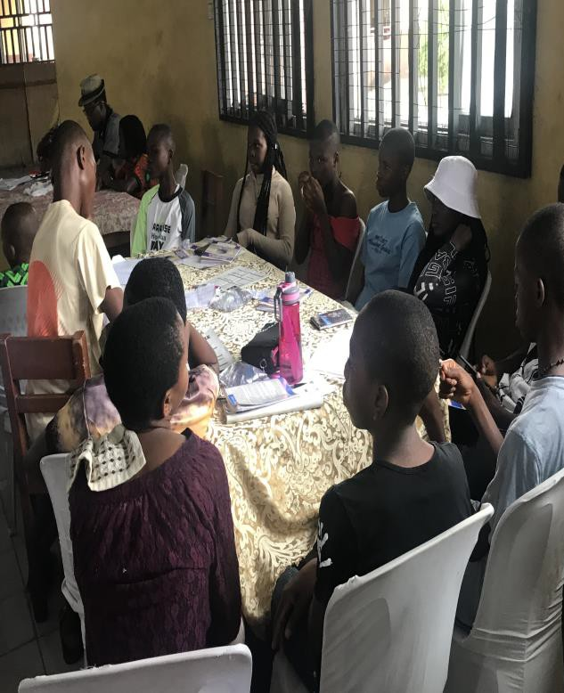PICTURE GALLERY
Cross Section of Participants at the 2024 Peace Camp Lectures Ongoing
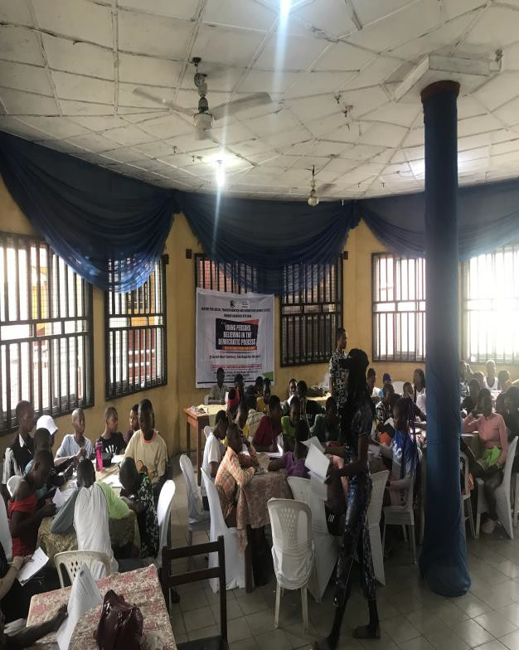

Cross Section of Participants at the 2024 Peace Camp Lectures Ongoing
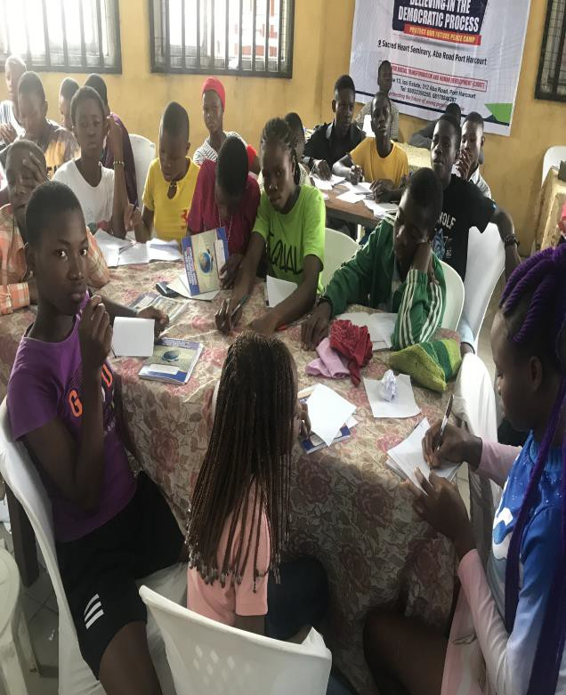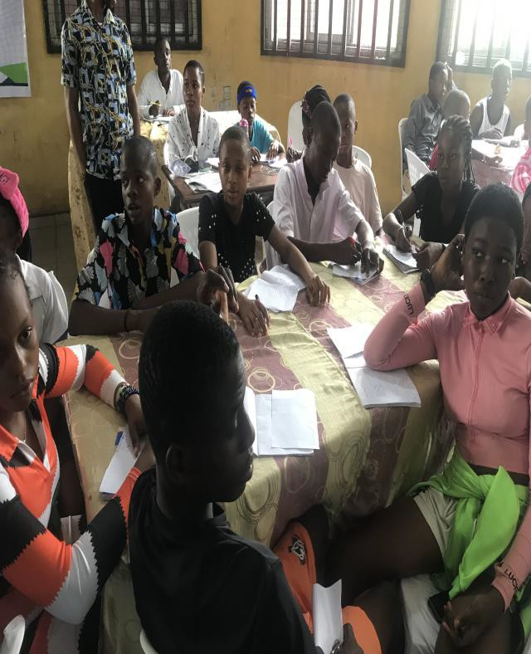

Cross Section of Participants at the 2024 Peace Camp Lectures Ongoing

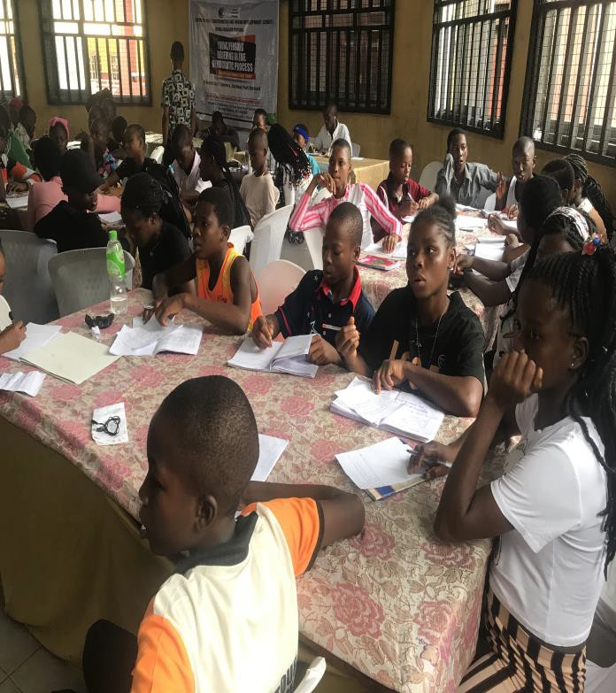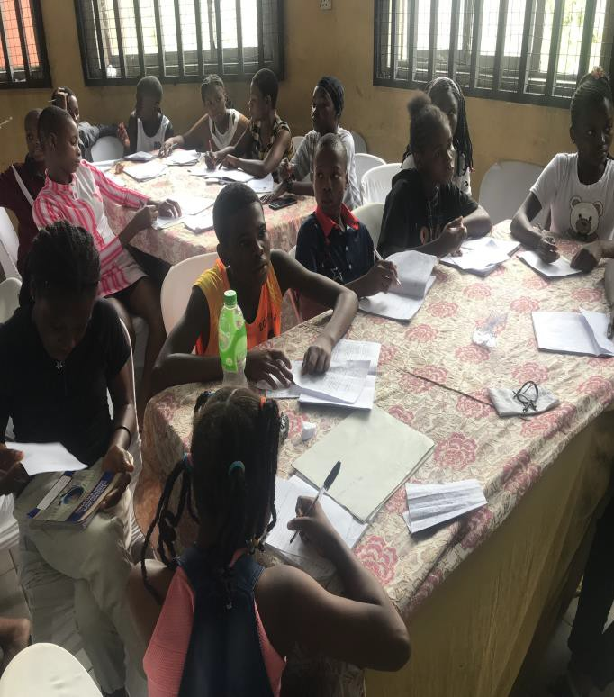

Cross Section of Participants at the 2024 Peace Camp Lectures Ongoing

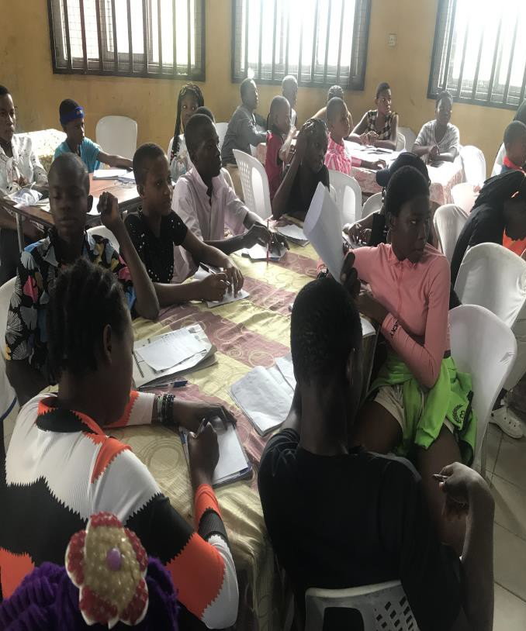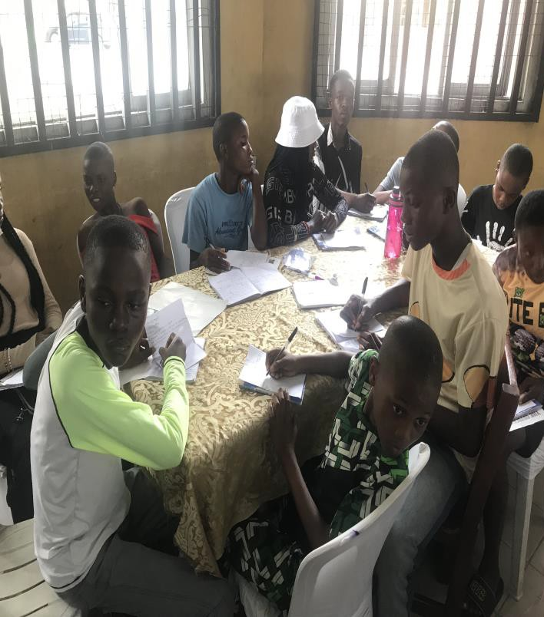

Cross Section of Participants at the 2024 Peace Camp Lectures Ongoing

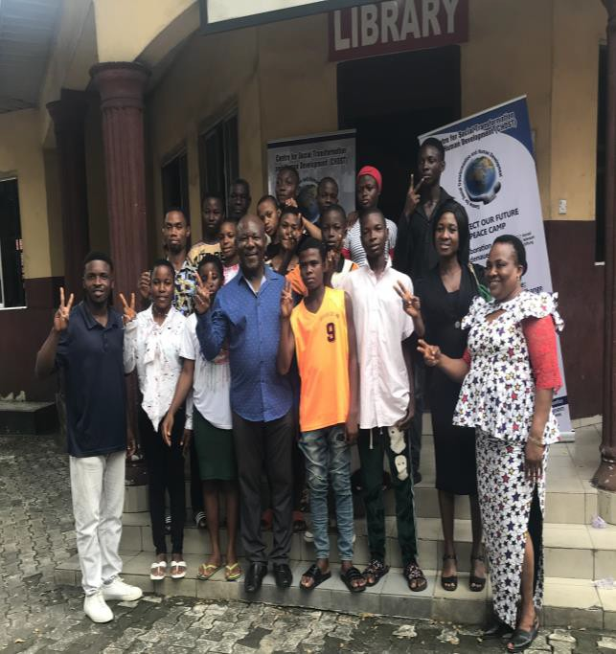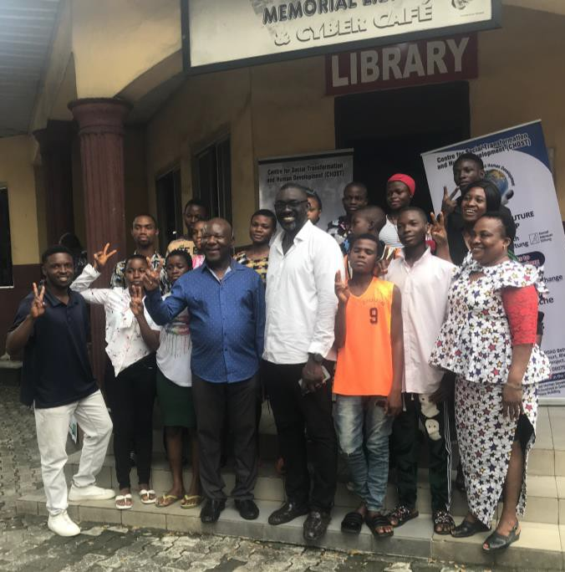

Group Picture of Imo Participants with Prof Ernest E. Uwazie founder ASDF, Dr Collins Imoh CHDST Coordinator, ASDF Coordinator Iwuamadi Sunday Chimaobi and Imo Peace Club Teacher Coordinators.
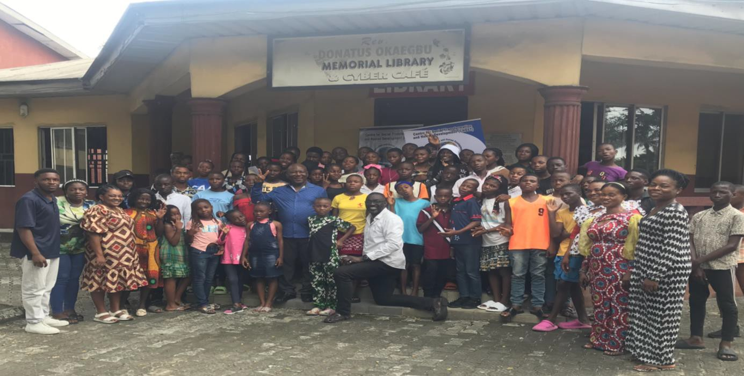
Group Picture of all Participants at the 2024 peace camp held in Rivers state,Port Harcourt,Nigeria with Prof Ernest E. Uwazie founder ASDF, Dr Collins Imoh CHDST Coordinator, ASDF Coordinator Iwuamadi Sunday Chimaobi and all participating school Peace Club Teacher Coordinators.

Compiled and edited by:

Iwuamadi Sunday Chimaobi
A.g Coordinator.

